Getting started with Smart Forms (Building a simple application)
By Sunitha
Go to transaction “Smartforms”.
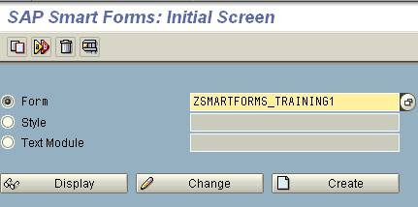
Enter a name for the form and click on Create.
Enter a short description for the form.
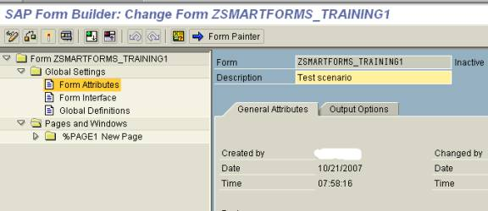
In this example, we will print a simple text using our form. To create a text, expand “Pages and Windows” → New Page. Select Main Window and Right click on that. Select Create → Text
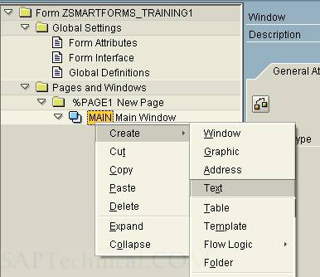
Give a name to the text and short description.
Also enter the text you want to see on the form.
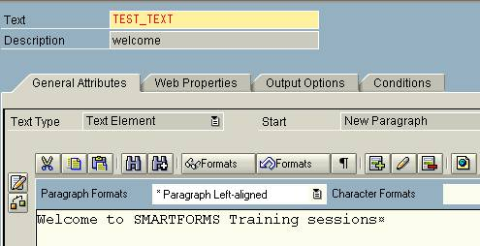
SAVE and Activate the Smart form.
To know the function module that is generated upon activation of this smart form, click on Environment → Function module name.
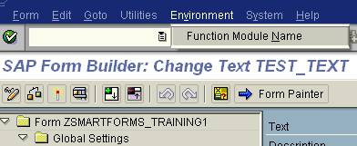
Following popup with the function module would appear.
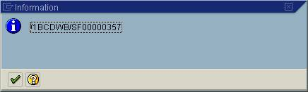
Test the smart form by clicking on Test. You would be navigated to the function builder with the function module defaulting to the one that is generated earlier.
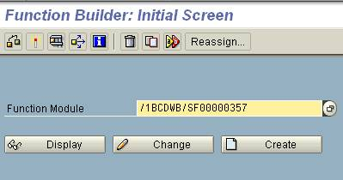
Click on execute.
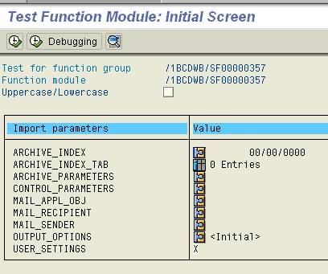
Since we do not have any parameters to pass on, click on Execute.
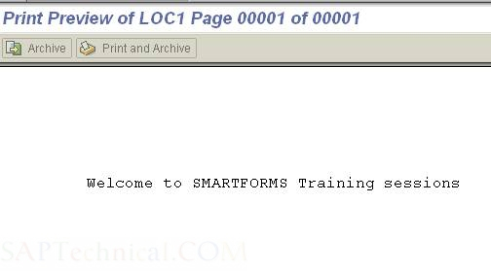

Printing Address using Smart Forms
By Sunitha
Go to transaction “Smartforms”.
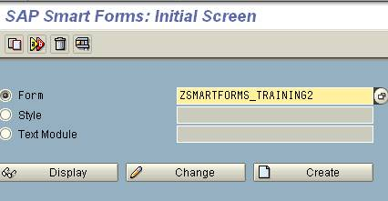
Enter a name for the form and click on Create.
Enter a short description for the form.
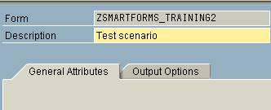
Expand “Pages and Windows” and click on “%PAGE1”. Rename the page to your needs and add a short description to the same.
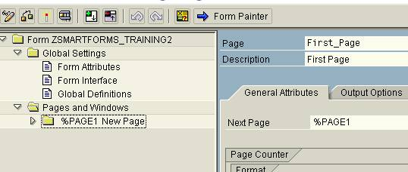
To display the address on the form, right click on “Main Window”, select Create → Address
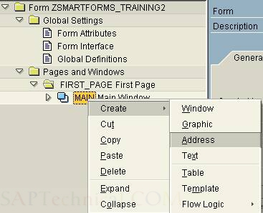
Following screen appears.
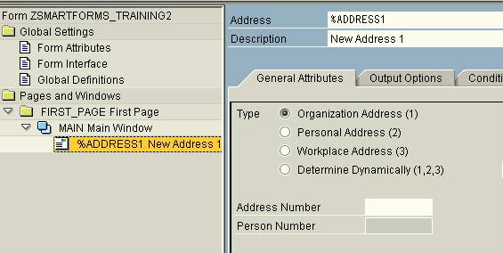
Enter a name to the Address and add a short description for the same.
You all might be aware that Addresses are stored in the table ADRC. Now pick an address number from that table, add provide the same in the “Address Number” as shown below:
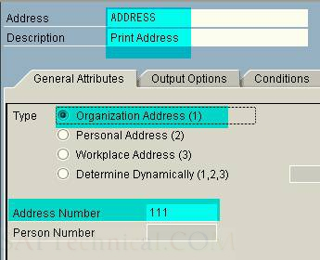
Save and Activate the form.
Now execute the Smart form. The output would be similar as shown below:
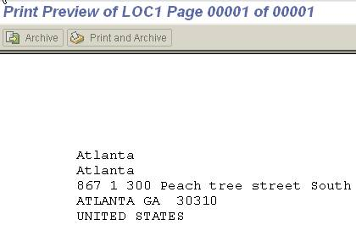

Calling Smart Form using Driver Program
By Sunitha
Let us prepare a driver program for the Smart Form that displays the address (Click here to for the demo on ADDRESS). This is a simple demo and doesn’t contain any parameter passing in this example.
Check the function module that is generated when the Smart Form is activated by clicking on Environment → Function Module Name.
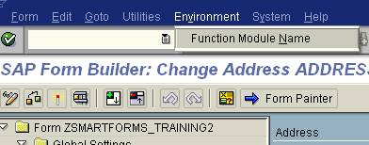
A pop up would appear displaying the function module name.
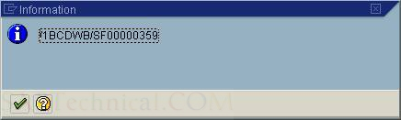
We would use this function module in our driver program to call this function module.
Let us create a driver program with a simple call to the above generated function module:
REPORT Zcall_smartform.
* To call a smart form, we would need to call the function module that
* is generated.
* Calling the generated function module directly is not an efficient
* method. For efficient method, click here.
CALL FUNCTION '/1BCDWB/SF00000359'
* EXPORTING
* ARCHIVE_INDEX =
* ARCHIVE_INDEX_TAB =
* ARCHIVE_PARAMETERS =
* CONTROL_PARAMETERS =
* MAIL_APPL_OBJ =
* MAIL_RECIPIENT =
* MAIL_SENDER =
* OUTPUT_OPTIONS =
* USER_SETTINGS = 'X'
* IMPORTING
* DOCUMENT_OUTPUT_INFO =
* JOB_OUTPUT_INFO =
* JOB_OUTPUT_OPTIONS =
* EXCEPTIONS
* FORMATTING_ERROR = 1
* INTERNAL_ERROR = 2
* SEND_ERROR = 3
* USER_CANCELED = 4
* OTHERS = 5
.
IF sy-subrc <> 0.
* MESSAGE ID SY-MSGID TYPE SY-MSGTY NUMBER SY-MSGNO
* WITH SY-MSGV1 SY-MSGV2 SY-MSGV3 SY-MSGV4.
ENDIF.
Execute the program for the output.
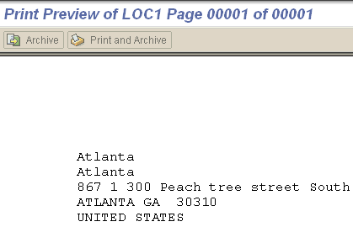

Importance of the function module SSF_FUNCTION_MODULE_NAME
A function module is generated whenever a Smart Form is activated. This Smart Form could be called from the driver program by calling this function module as shown below:
REPORT Zcall_smartform.
CALL FUNCTION '/1BCDWB/SF00000359'
* EXPORTING
* ARCHIVE_INDEX =
* ARCHIVE_INDEX_TAB =
* ARCHIVE_PARAMETERS =
* CONTROL_PARAMETERS =
* MAIL_APPL_OBJ =
* MAIL_RECIPIENT =
* MAIL_SENDER =
* OUTPUT_OPTIONS =
* USER_SETTINGS = 'X'
* IMPORTING
* DOCUMENT_OUTPUT_INFO =
* JOB_OUTPUT_INFO =
* JOB_OUTPUT_OPTIONS =
* EXCEPTIONS
* FORMATTING_ERROR = 1
* INTERNAL_ERROR = 2
* SEND_ERROR = 3
* USER_CANCELED = 4
* OTHERS = 5
.
IF sy-subrc <> 0.
* MESSAGE ID SY-MSGID TYPE SY-MSGTY NUMBER SY-MSGNO
* WITH SY-MSGV1 SY-MSGV2 SY-MSGV3 SY-MSGV4.
ENDIF.
But this is not an efficient way of calling Smart Form for the following reason:
Whenever a Smart Form is generated, a function module is generated and the naming convention for that Smart Form is done internally by using Number range object or something similar. In the above case, the function module name is /1BCDWB/SF00000359. The function module for the next new and activated Smart Form would be /1BCDWB/SF00000360.
So when this Smart Form is transported from the development to Quality or Production system, a new function module name is generated according to the number series available in that system. If the above program is transported to either quality or production system, the program might go for a dump as the function module is not available in that system. To handle this situation, we use the function module SSF_FUNCTION_MODULE_NAME to get the name of the function module for a Smart Form dynamically. If the form is not active, the function module SSF_FUNCTION_MODULE_NAME raises the exception NO_FORM.
Look at the modified program below:
REPORT zcall_smartform.
DATA:
fname TYPE rs38l_fnam.
call function 'SSF_FUNCTION_MODULE_NAME'
exporting
formname = 'ZSMARTFORMS_TRAINING2'
* VARIANT = ' '
* DIRECT_CALL = ' '
importing
fm_name = fname
* EXCEPTIONS
* NO_FORM = 1
* NO_FUNCTION_MODULE = 2
* OTHERS = 3
.
IF sy-subrc <> 0.
* MESSAGE ID SY-MSGID TYPE SY-MSGTY NUMBER SY-MSGNO
* WITH SY-MSGV1 SY-MSGV2 SY-MSGV3 SY-MSGV4.
ENDIF.
* Now replace the function module name '/1BCDWB/SF00000359'
* with the variable FNAME
CALL FUNCTION FNAME
* EXPORTING
* ARCHIVE_INDEX =
* ARCHIVE_INDEX_TAB =
* ARCHIVE_PARAMETERS =
* CONTROL_PARAMETERS =
* MAIL_APPL_OBJ =
* MAIL_RECIPIENT =
* MAIL_SENDER =
* OUTPUT_OPTIONS =
* USER_SETTINGS = 'X'
* IMPORTING
* DOCUMENT_OUTPUT_INFO =
* JOB_OUTPUT_INFO =
* JOB_OUTPUT_OPTIONS =
* EXCEPTIONS
* FORMATTING_ERROR = 1
* INTERNAL_ERROR = 2
* SEND_ERROR = 3
* USER_CANCELED = 4
* OTHERS = 5
.
IF sy-subrc <> 0.
* MESSAGE ID SY-MSGID TYPE SY-MSGTY NUMBER SY-MSGNO
* WITH SY-MSGV1 SY-MSGV2 SY-MSGV3 SY-MSGV4.
ENDIF.

Displaying Graphics using Smart Forms
Go to transaction SE78 (Administration of Form Graphics).
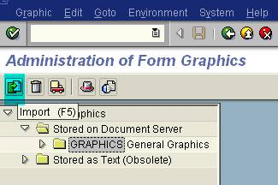
Double-click on “GRAPHICS” node and click on “Import (F5)” to import the image.
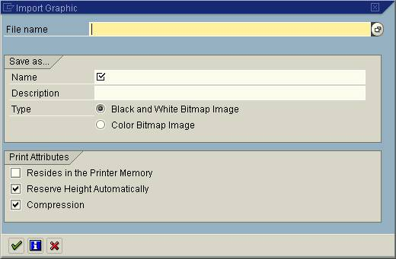
Select the file name by using the F4 functionality available. Name your graphic and enter a short description. If you have color image, select the radio button “Color Bitmap image”. Click on tick mark to proceed.
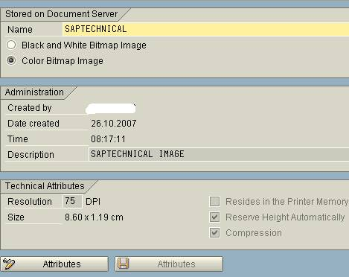
The graphic is imported and is stored in “Business Document Server”.
You can test this by selecting print preview:
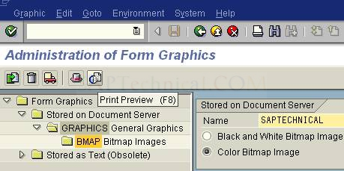
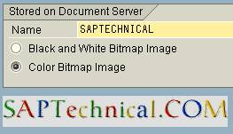
Now go to transaction SMARTFORM.
Create a new form and give a short description for the same.
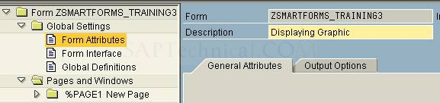
To display an image, right click on Main Window → Create → Graphic
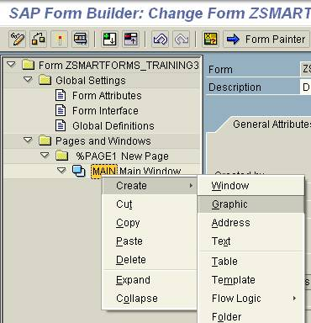
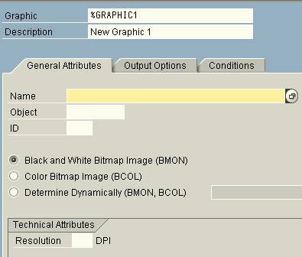
Use F4 help to fill the fields.
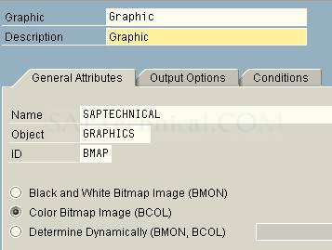
Save and activate the workflow.
Test run the smart form, to check the appearance of the graphic.

Passing data to the Smart Forms
Scenario: Let us take a simple scenario of passing Material Number and Material description from Driver program to the Smart Form.
Go to transaction SMARTFORMS and create a Smart Form.
To pass the values from the driver program to Smart Form, we need to define the form interface with the parameters to be passed on.
Click on Global Settings → Form Interface.
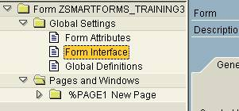
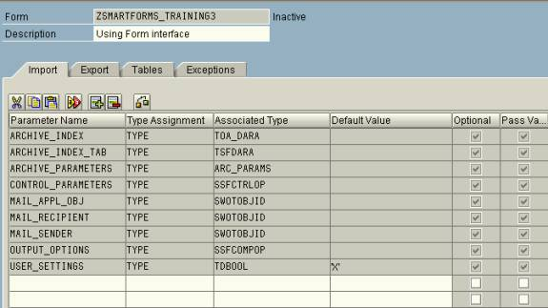
Now define the import parameters for MATNR and MAKTX (From table MAKT)
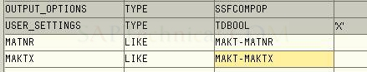
Now create a Text in the Main window to display the above two parameters.
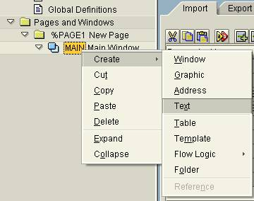
To add a field, we need to click on “Insert Field”.
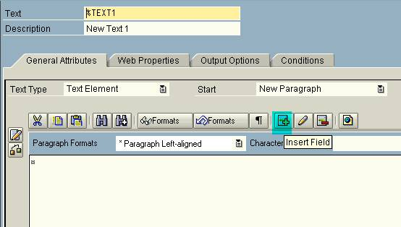
Enter the field names between the ‘&’ (Ampersand) as shown below:
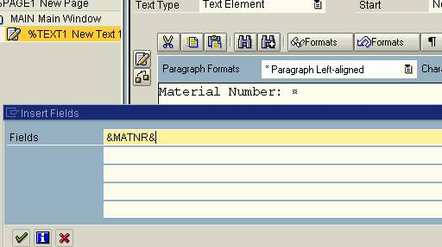
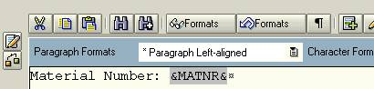
Similarly create for Description.
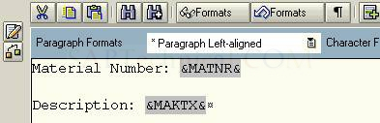
Save and Activate the Smart Form. Test run the Smart Form by clicking on Execute.
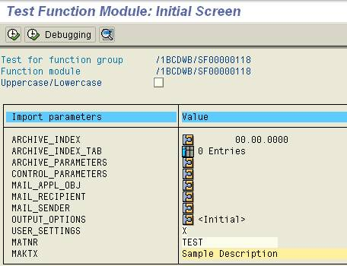
Enter the values as shown below and click on execute.
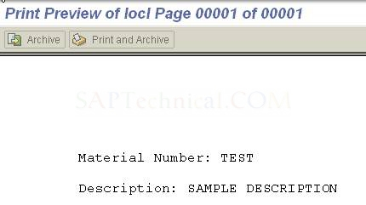

Working with Global Definitions and Program Lines
Scenario: To calculate the total seats available using the values “Maximum seats available” and the “Occupied seats”. In this case, we would be defining Maximum Seats and Occupied Seats in the form interface and Seats Available in the Global definitions. We would write some code to calculate Seats available and then print the same.
Procedure: Create a new smart form and, in the Form Interface, define the following two fields: (To know about Form Interface, click here. )
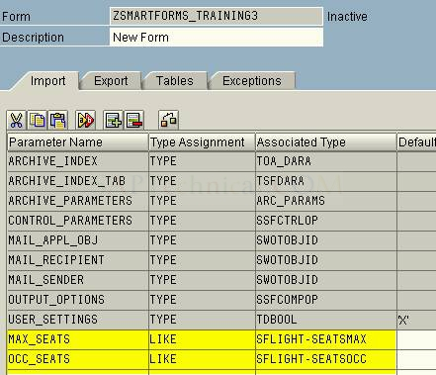
Now click on “Global definitions” :
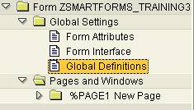
Now define a variable, SEATS_AVAIL
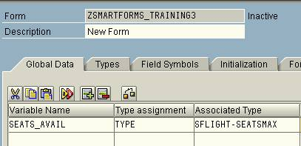
Now to calculate Seats Available, select Main Window → Create → Flow Logic → Program Lines
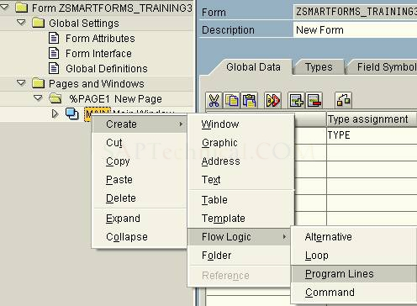
Now mention the input parameters as SEATS_MAX and SEATS_OCC and the output parameter as SEATS_AVAIL. Write the code to calculate SEATS_AVAIL.
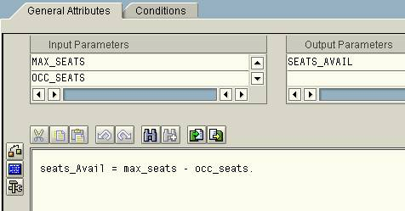
Now to print these values on the layout, create a text by selecting Main Window → Create → Text:
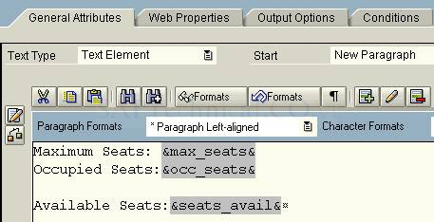
Save and do the syntax check. Activate the Smart Form.
Test the smart form by clicking on F8. Enter some values for max_seats and avail_seats
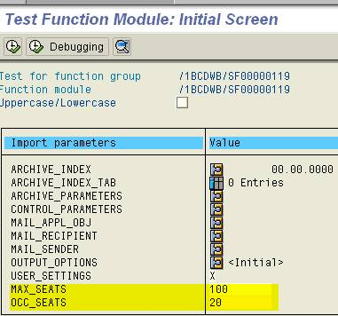
Execute the function module.
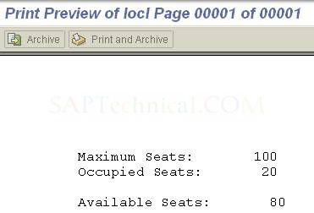

Working with Secondary Window
Create a Smart Form using the transaction SMARTFORMS.
To create a Secondary Window,
Right click on Page → Create → Window (as shown below)
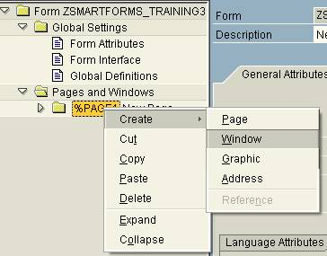
A secondary window is created.
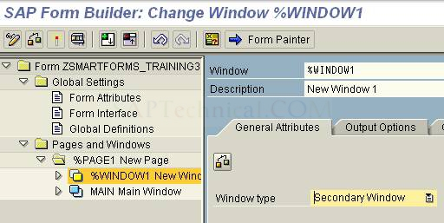
To position the secondary window to meet our needs, click on Form Painter.
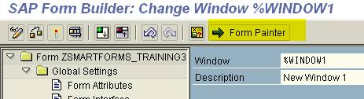
Following screen appears:
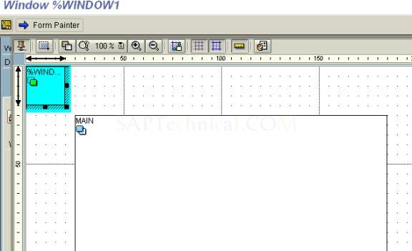
The highlighted window in the above screenshot is the secondary window.
Move the secondary window (and even stretch) according to your needs.
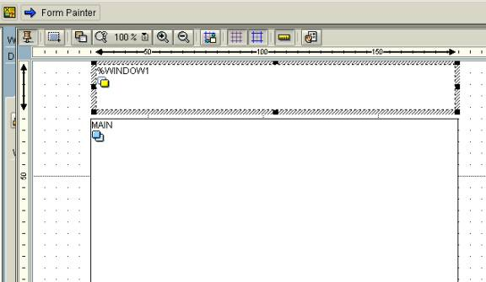
To close the above page design, click on Form Painter again.
Now let us write some content in these areas.
Now select the Page → Secondary Window
Right click on Secondary Window → Create → Text
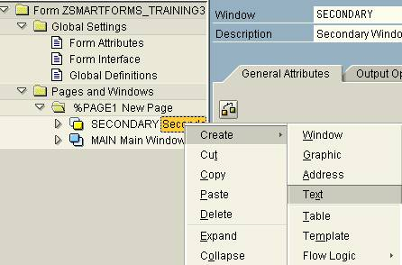
Write some text inside.
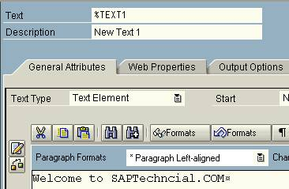
Similarly, create some text in the Main window as well.
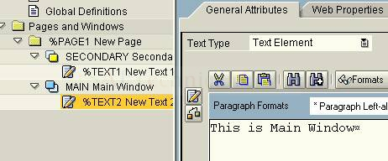
Save and activate the Smart Form. Test run the Smart Form; you would get the following output:
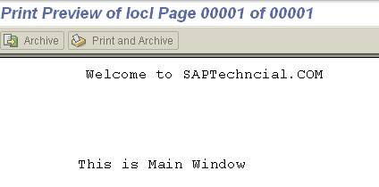

Demo on Copies Window (Real time scenario)
Scenario: To print three copies of a particular document and the first copy should mention as Customer copy, second one as Bank copy and the third one say College copy.
Create a Smart Form using the transaction SMARTFORMS.
In this demo, we would print in the Copies window whether it is bank copy, company copy or others.
Create a secondary window as shown below:
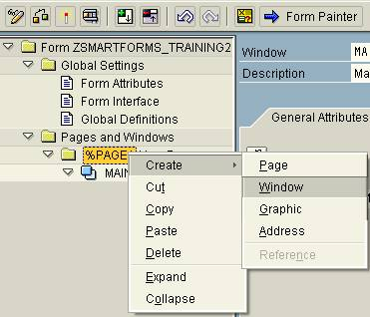
Select Window type as “Copies Window” as shown below:
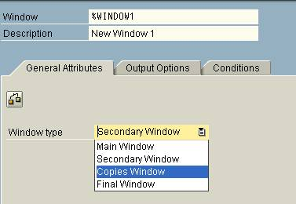
Also name your window and give it a proper description. Do not change any other settings.
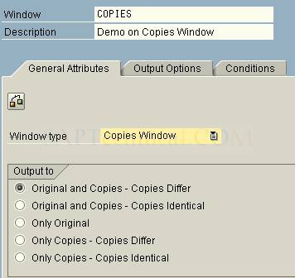
Adjust the window size using the Form Painter available on the application toolbar.
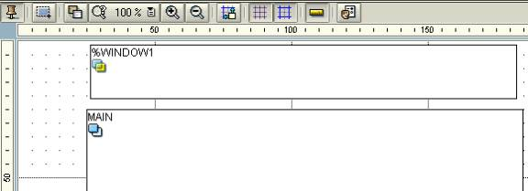
The variable SFSY-COPYCOUNT would provide us count of the copy whether it is a first copy, second copy and others. We would use this field to print the owner of the copy.
We would define a string, which would hold the name of the copy (bank copy and others) depending on the value of SFSY-COPYCOUNT. Define a variable in the global definition as shown below:
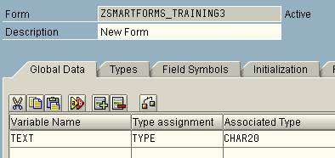
Now select your Copies window, right click – Select Create → Flow Logic → Program Lines
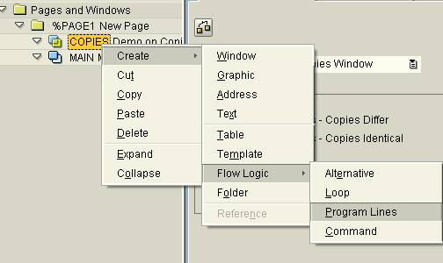
Enter the following code:
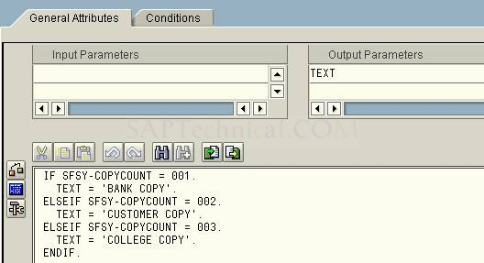
Do not forget to enter the variable TEXT in the output parameters.
Now create a text by selecting the Copies window, right click Create → Text.
In this, just enter the field name as shown below by selecting insert field.
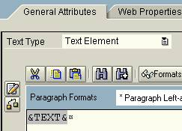
Now include a text in the Main window as well with some content.
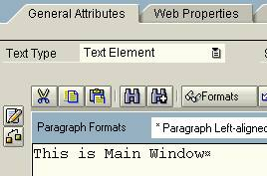
Save and activate. Test your Smart Form.
In the print preview screen, enter the number of copies as 3
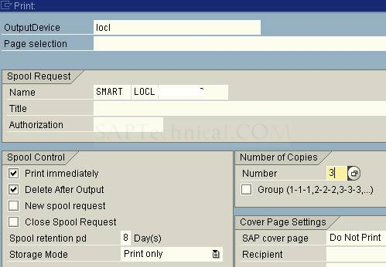
Check the output:
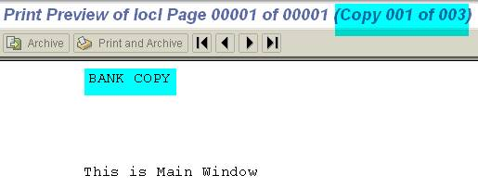
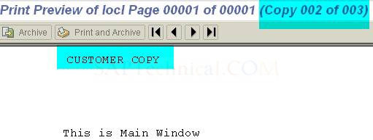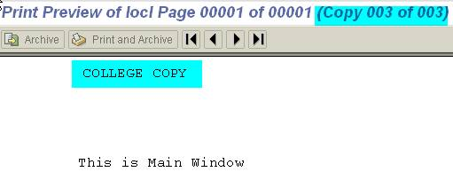

Working with Smart Styles
By Swathi, Wipro
Scenario: In this demo, we would create a small text as shown below with outline numbering as shown below
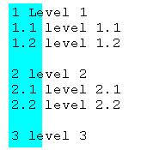
Go to transaction “SmartStyles”
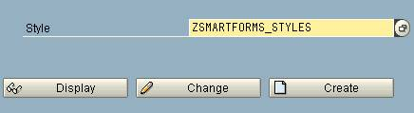
Enter a style name and click on Create.
Following screen appears:
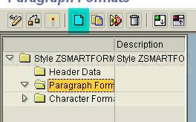
To create a paragraph, click on folder “Paragraph Formats” and click on Create (as shown in the above screenshot).
Following pop-up appears: Enter a paragraph format name.
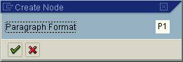
Enter a suitable description for your graph and enter the left margin value as 2 CH.
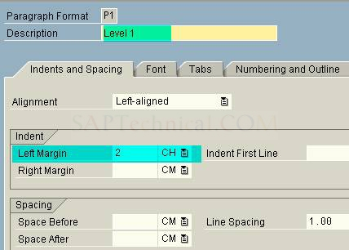
Now select the tab “Numbering and Outline”:
Enter the Top Outline Paragraph as the current paragraph name and select “1,2,3..” from the list for the Numbering Type.
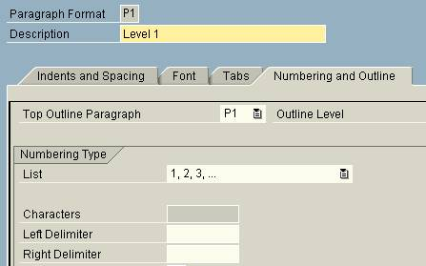
Now create another paragraph format P2 as per the above method.
In the tab “Numbering and Outline” of P2, do the following:
Select the “Top Outline Paragraph” as “P1” and put the left delimiter as “.”. If the left delimiter is not mentioned, the values would be displayed as “11, 12, 13...” instead of “1.1, 1.2, 1.3…”
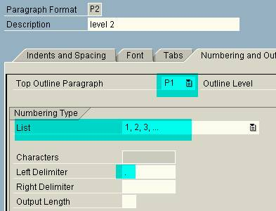
Also, in the same window, check the “Number Chaining” Box. If this is selected, the parent value would be displayed (like 1.1, 1.2, 2.1,2.2..). If this is not checked, only numbering would appear like 1, 2,3 without the parent number prefixing.
Save and activate your Smart Style.
Now go to transaction “SmartForms”.
Create a Smart Form and create a text in the Main Window:
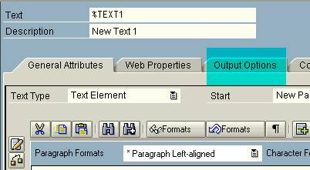
Select the tab “Output Options” to mention the Smart Style to be used.
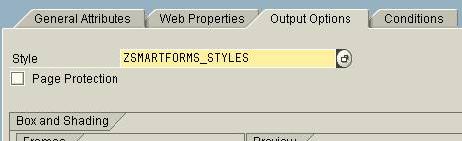
Now go to tab “General Attributes”.
Select the icon “Txt Editor” (Though the text could be written directly on this screen, we are avoiding this method for easy understanding to the consultants who are used with SAP Script editor)
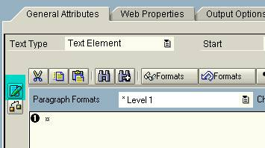
Now to change the editor, Click on “Goto” -> Change Editor
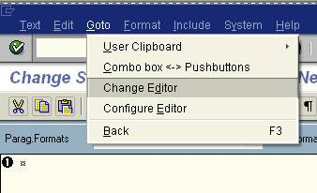
Here enter the desired text:
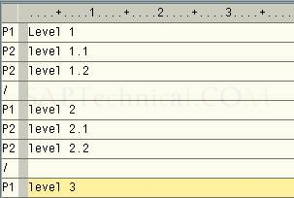
Return to the main screen of the Text. The screen would appear as follows:
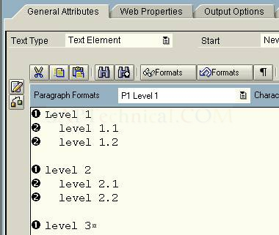
Save and activate the Smart Form. Test run the Smart Form. Following would be the output:
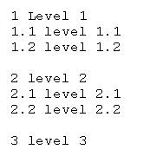

Smart Forms - Working with Loop
By Venkat
Step1: Provide the name of the smart form is YDEMO_LOOP on the initial screen of the smart form and meaningful description.
Step2: Now go to Global definitions where we can define the Global data, Types, Initialization and etc.
Define Structure using Types Parameter as shown below. In Types parameters we usually define user defined data types.
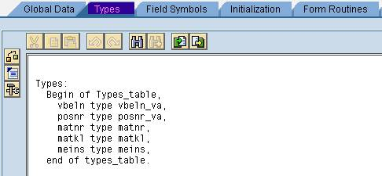
Step3: Now define the internal table and work area in Global Data parameter.
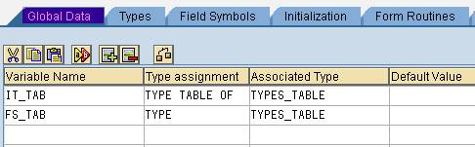
Step4: In Initialization parameter, we can write a code as shown below. We have to mention the output result in the output parameter so that we can use it further. Here in this case we are outputting IT_TAB and we are going to use this IT_TAB further in the LOOP in the Flow Logic.
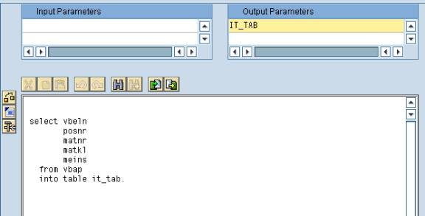
Step5: Create a LOOP statement as shown below.
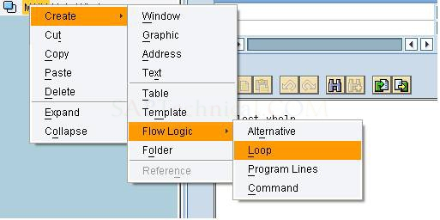
Step6: Now Loop the internal table.
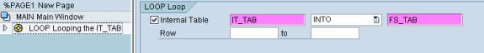
Step7: To create the character, paragraph formats and Tabs, we use the smart style. The transaction for create smart style is SMARTSTYLE or we can be created the initial screen of SMARTFORMS. Here SMART STYLE is created to define Tab positions for the columns.
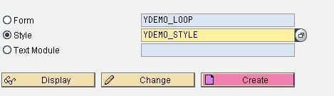
Step8: Create a node for PARAGRAPH FORMAT as shown below.
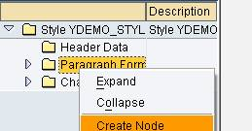
The following screen appears.
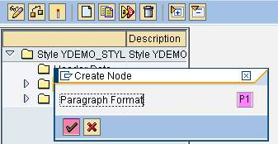
Step9: Now define the Tabs as shown below.
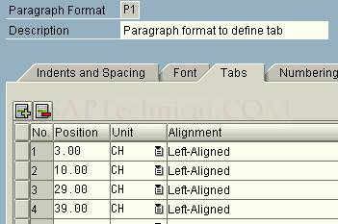
Step10: Now Import SMART STYLE in to the SMART FORM as shown below.
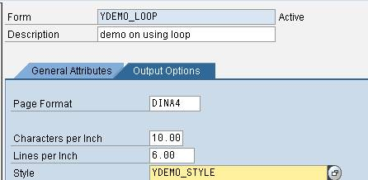
Step11: Now create a text element for the loop statement.
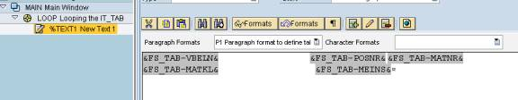
Step12: Save and activate the smart form. The output is as shown below.
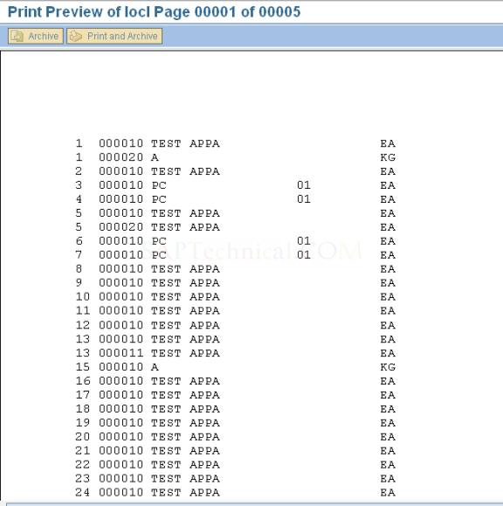

Designing Tables in Smart Forms
By Venkat
Step1: T-code for smart forms is “SMARTFORMS”. Provide the name of the smart form.
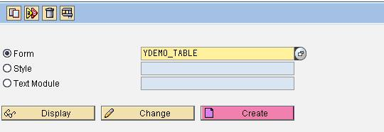
And provide the short text for this smart form “YDEMO_TABLE”.
Step2: Now go to Global definitions where we can define the Global data, Types, Initialization and etc.
Define Structure using Types Parameter as shown below. In Types parameters we usually define user defined data types.
Step3: Now define the internal table and work area in Global Data parameter.
Step4: In Initialization parameter, we can write a code as shown below. We have to mention the output result in the output parameter so that we can use it further. Here in this case we are outputting IT_TAB and we are going to use this IT_TAB further in the Table painter.
Step5: Now we create a Table painter as shown below.
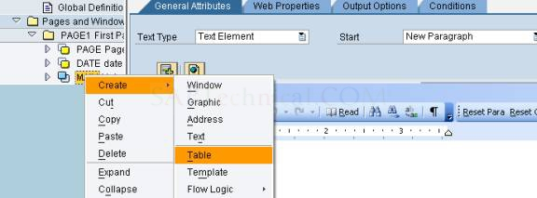
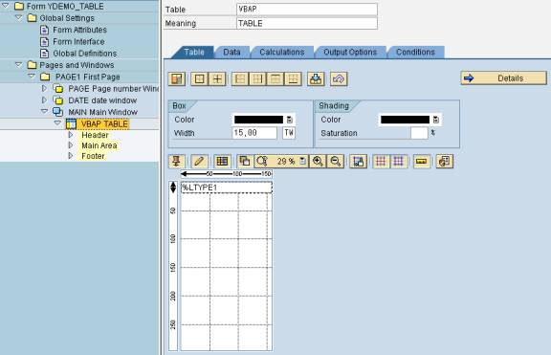
Step6: Now we define number of table columns in %LTYPE1. Here, %LTYPE1 is renamed as LINE as shown below.
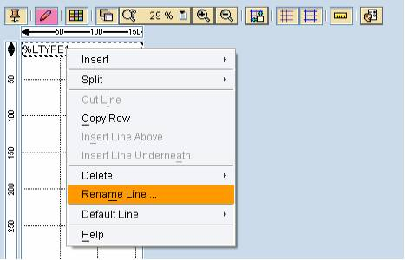
Here, in this scenario we have to divide the LINE area into 4 columns as we have to display 5 columns. To draw a line we have to select Draw lines and columns button as shown above.
Step7: Now we have to create Table line for Header and Main area of Table painter as shown below.
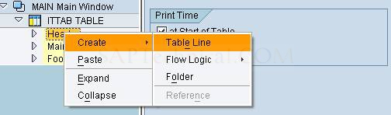
Here we have to provide line type. Here, the line type is LINE.
Step8: Provide the text for all columns.
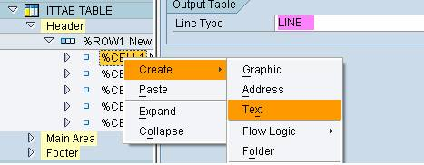
Step9: Repeat the same process to the Main Area too.
Step10: Now Loop the internal table data as shown below.
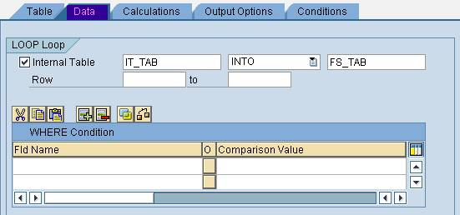
Step11: Save and activate the smart form. Execute the smart form now. The output is as shown below.
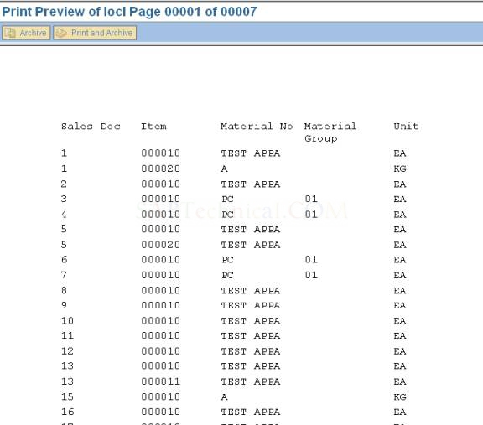

Using MS Word as Editor in SAP Script and Smart Forms
By Surekha
This document details the procedure in using Microsoft Word as editor in SAP Script / Smart Forms.
In normal case, when you try opening the editor in Smart Forms, the following editor would appear:
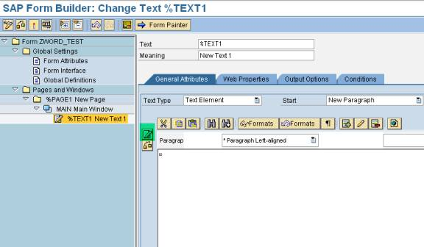
Click on the editor button. The following editor appears:
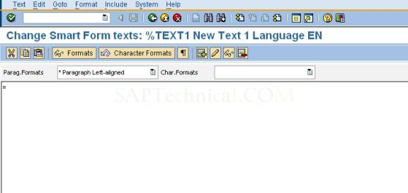
Now to change the above editor to MS Word, do the following:
Go to transaction I18N (Internationalization).
Click on I18N Menu → I18N Customizing → I18N System Configuration (as shown in the screenshot below)
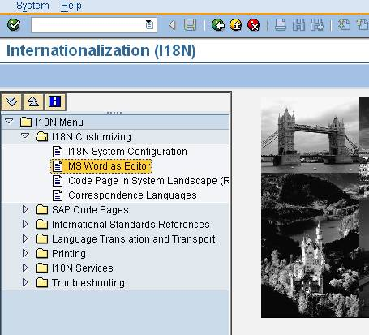
The following screen appears:
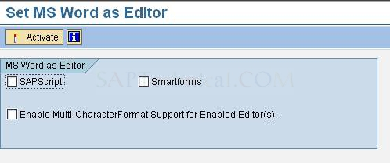
If you would like to use MS Word Editor in both Script and Smartforms, then check the both checkboxes as shown below:
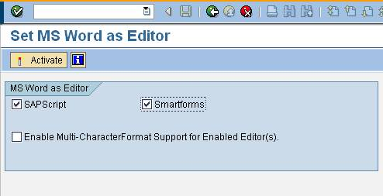
Click on Activate.
The following popup appears (related to SAPScript Editor):
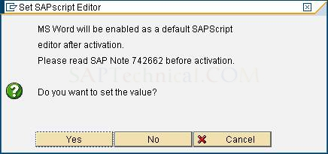
Click on Yes. Now the following popup appears (related to Smartforms Editor):
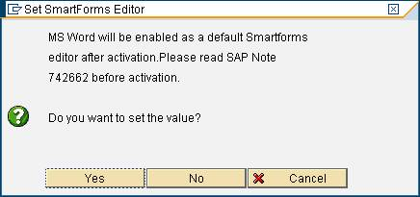
Click on Yes to proceed.
Now the MS Word editor is available for both SAP Script and Smartforms.
Result: In the SmartForms:
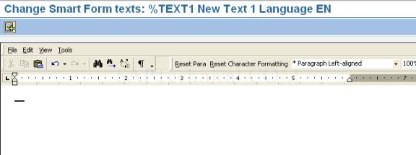
In SAP Script:
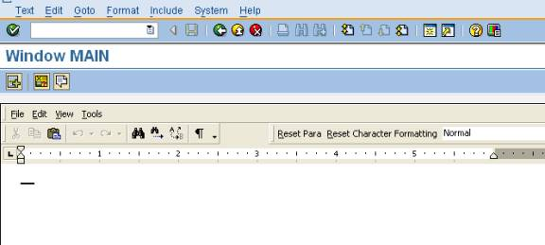
You can anytime revert to old editor by deactivation MS Word editor option using the transaction I18N.

Achieving control-break statements functionality in Smart Forms
By Phani Diwakar, YASH Technologies
Step1: T-code for smart forms is “SMARTFORMS”. Provide the name of the smart form.
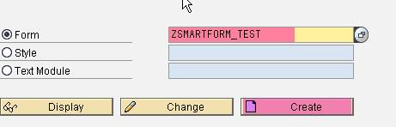
Step2: we can define user-defined structure in TYPES tab in the Global Definitions.
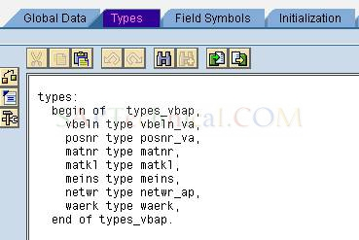
Step3: Define the field string, internal table and global variables in Global Data tab.
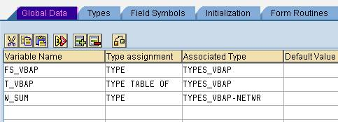
Step4: In the Initialization tab,
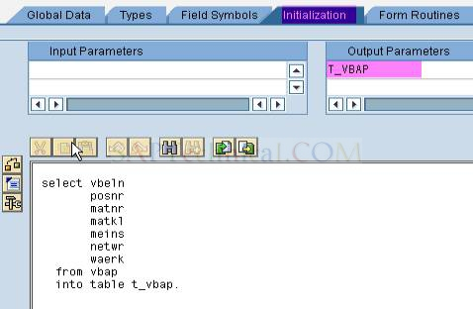
Step5: In main window, create the loop as shown below.
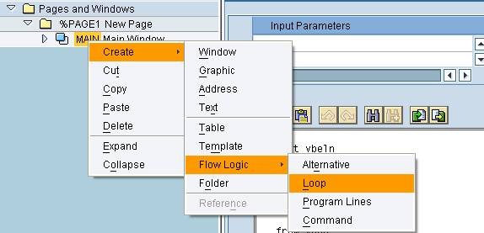
Step6: Now Loop the internal table.
Create text element in this loop as show below.
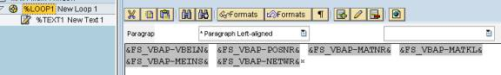
Step7: Execute the smart form, the output would be 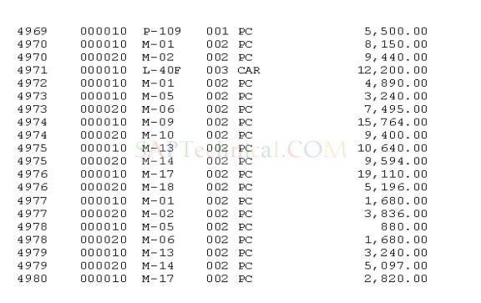
Step8: suppose, if we want to know the item details sales document wise. To achieve this, we have to write the events in the loop as shown below.
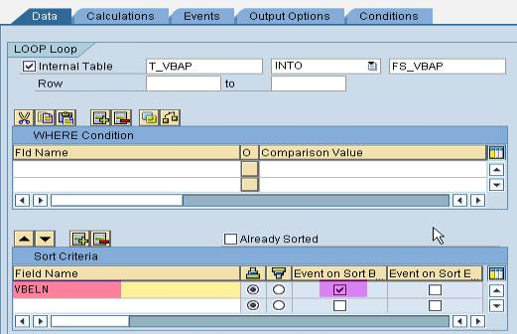
And in the event on sort begin,
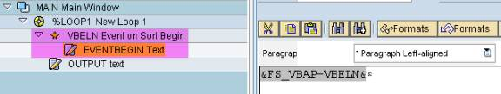
In the text element,
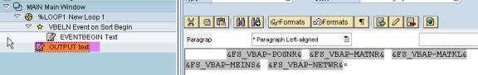
Step9: Now execute the smart form, the output would be
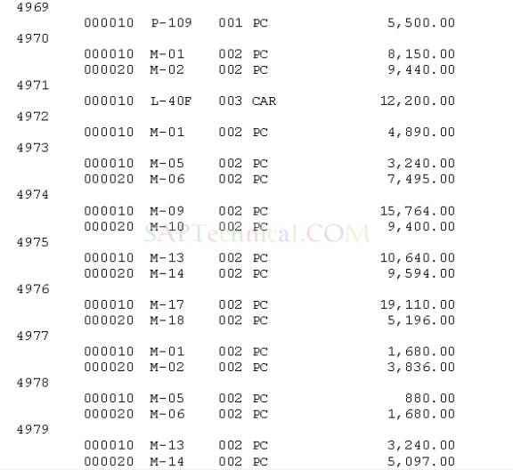
Step10: Now the requirement is to sum the net price of all items of sales document. To achieve this,
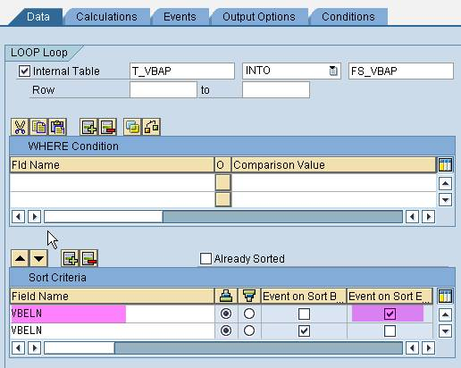
And in the program lines, we have to add the net price.
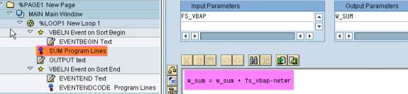
In the event on sort end,
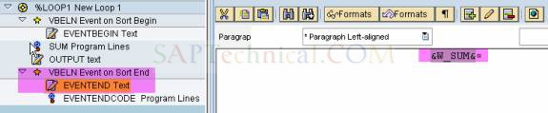
In program lines,
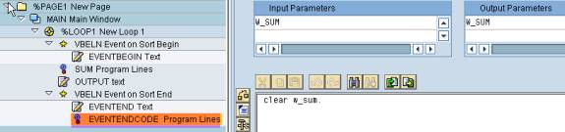
Step11: Now execute the smart form, the output would be
