Building interactive BSP Application
This documents describes the How to handle Interactive reporting (Extension to BSP Application1 document).
Step1: Create the BSP Application ZBSP_TABLE_EXT and page name First.htm.
Step2: Provide the select-option on the screen.
Step3: when particular table row is selected then the corresponding detailed information should be displayed.To achieve this functionality, we have to select selectionMode, onRowSelection, keyColumn in tableview tag as shown.
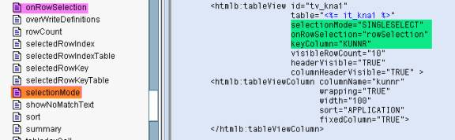
Step4: Consider the Tableview event handler too along with Inputfield event handler in the EVENT HANDLER.
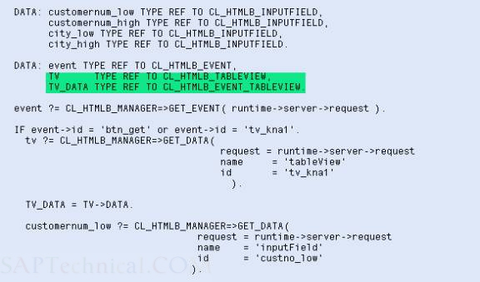
Step5: The code should be written as follows
The code in Layout is:
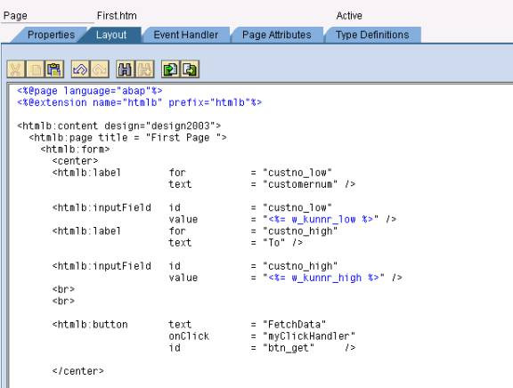
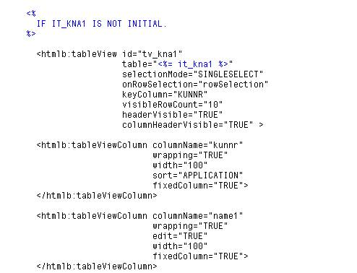
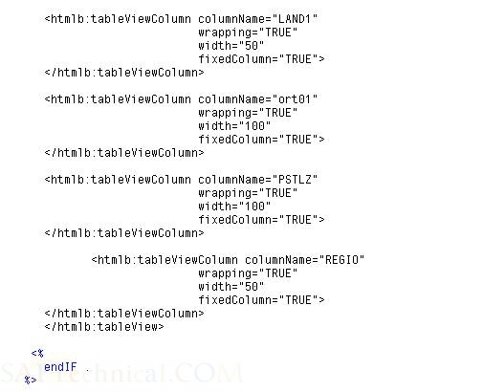
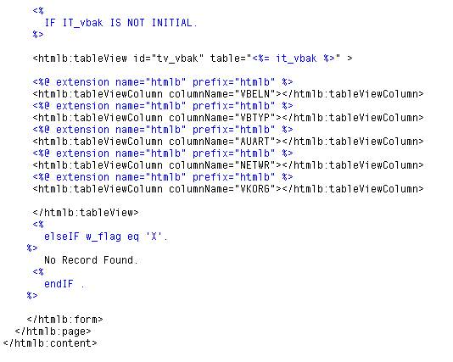

The code in the Event handler:
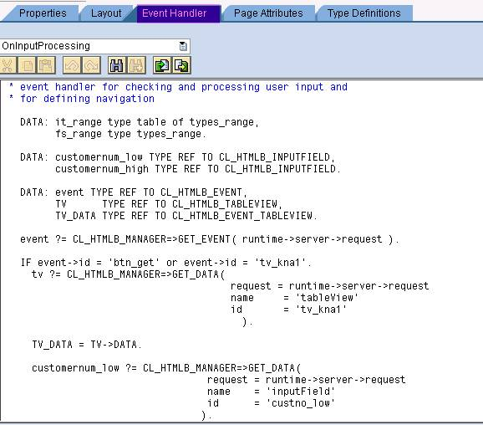
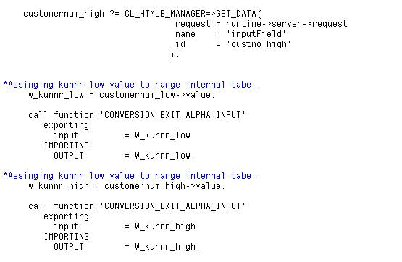
Here, row_key is a field in tv_data which contains the selected row value (Key value mentioned in the tableview).
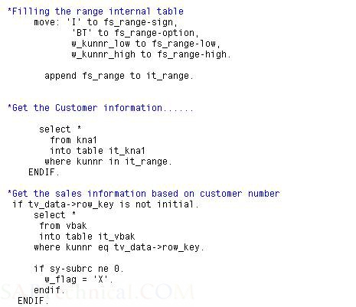
Define the page attributes as below:
fs_vbak TYPE VBAK Sales Document: Header Data
it_kna1 TYPE TYPES_KNA1 Internal table to hold customer information
it_vbak TYPE TYPES_VBAK Internal table to hold Sales information
w_flag TYPE C Flag
w_kna1 TYPE KNA1 General Data in Customer Master
w_kunnr_high TYPE KNA1-KUNNR Customer Number 1
w_kunnr_low TYPE KNA1-KUNNR Customer Number 1
Define Type definition as below:
types: types_kna1 type table of kna1,
types_vbak type table of vbak.
types:
begin of types_range,
sign(1),
option(2),
low type kunnr,
high type kunnr,
end of types_range.
Now execute the BSP Application

